Week 13. Elevator Five (motor control)

Our toy servo is not up to raising and lowering an elevator. We beef it up with a tougher motor. It requires additional power, that we control through the motor control chip, L293D. With this we can control the direction and speed of the motor. All of these parts are waiting for you at Tinkercad. In your Motor Menu please choose 60 RPM.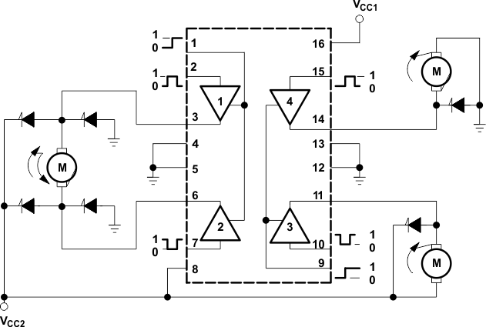
To get started let’s see how to set the direction and the speed using the L293D.
We will only need the motor control on the left side. We will use pin 1 to control the speed and pins 2 and 7 to control the direction. Let’s see how this works in practice.
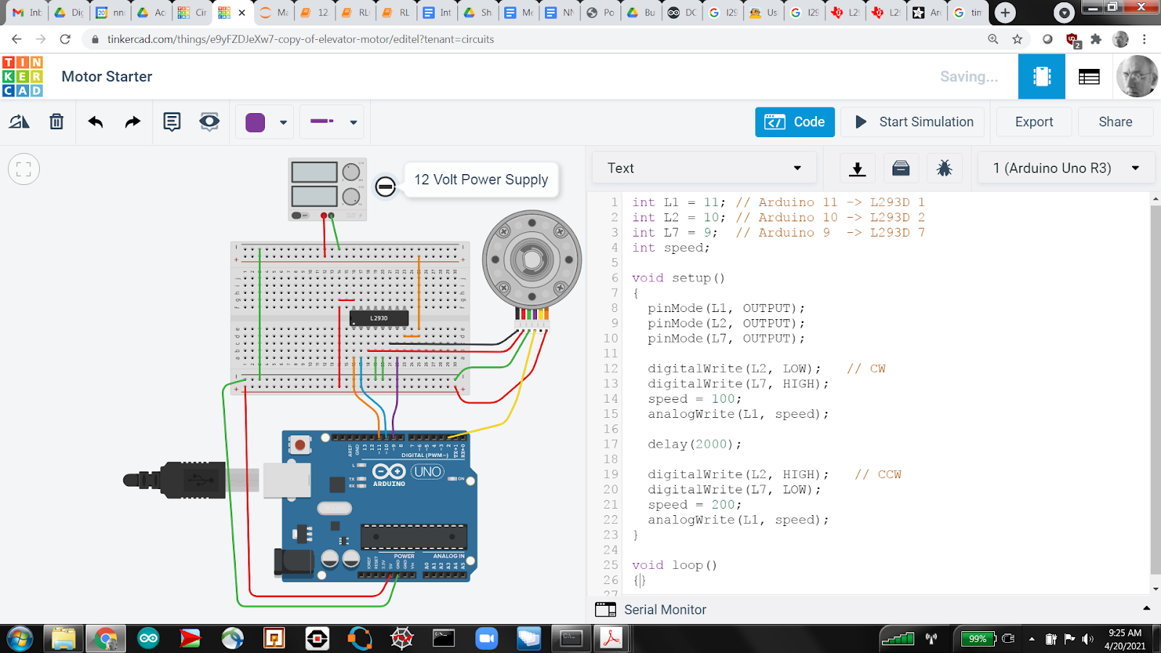
Please build and explore this circuit and code - changing speeds, directions, and delays. As our speed control is not merely HIGH or LOW we use analogWrite and as such MUST USE a PWM pin (those marked by a ~).

We imagine that the motor turns a shaft that spools and unspools a cable, on which the elevator car hangs.

If r denotes the radius of the shaft, then the car moves 2πr for every revolution of the shaft. For our purposes, let's suppose that

r = 0.5 cm

and that there are 12 cm between floors. The challenge then is to count the number of revolutions. To figure this out we’ll need to consult the motor/encoder specs

The key piece of information we gather from the spec sheet is

Encoder: Countable Events Per Revolution (Output Shaft) 6,678.624

This means that the encoder counts (encodes 6678 events per revolution (2 channel)) so
3339 events on our single channel - if we listen only to channel A.

You see that we have already wired the EncoderA pin to pin 2 of our Arduino. In order to use it please add this code to your preamble. Do the comments make sense?

int EnA = 2; // Arduino 2 -> EncoderA on Motor

volatile long EnAcount = 0; // counter variable

float radius = 0.5; // cm, radius of gear
float dist = 0; // distance traveled by elevator
float tprad = 2.0*3.14159*radius; // circumference of shaft is 2*pi*r

Our counter variable is volatile because we are going to update it while handling other tasks. In particular, we can use the notion of interrupts to increment EnAcount whenever pin 2 feels a change (i.e., whenever the encoder pulses it). Please note that interrupts are only possible on pins 2 and 3.

Now in order to set up the interrupt please add this code to your setup() routine

pinMode(EnA, INPUT_PULLUP);
attachInterrupt(digitalPinToInterrupt(EnA), updateEnA, CHANGE);

This latter line says to invoke your helper function, updateEnA, whenever the signal at pin EnA changes. Your helper function (placed below all code and all curly braces) is simply

void updateEnA()
{
EnAcount = EnAcount + 1;
}

We now have all the pieces needed to track the distance traveled. For example, if you replace your motor commands in setup() with

Serial.begin(9600);
digitalWrite(L2, LOW); // CW
digitalWrite(L7, HIGH);
speed = 100;
analogWrite(L1, speed);

while (dist < 2) { // vomit inducing
dist = EnAcount*tprad/3339;
Serial.println(dist);
}

speed = 0;
analogWrite(L1, speed);

you should see your motor turn clockwise until the distance traveled is 2, and then stop.

Why is EnAcount/3339 the number of revolution?

Is this how an elevator works? Set speed to 100 until you reach your destination then set speed to 0? I don’t think so.

To address this shortcoming we should
- Accelerate (slowly increase speed to maximum)
- Cruise (remain at maximum speed)
- Decelerate (slowly decrease speed to 0)

To accomplish this I recommend a new integer variable

int acc; // direction of speed change

that we set and use inside our distance loop. For example, if the distance between floors is 12, our scheme becomes
while (dist < 12) {
dist = EnAcount*tprad/3339; // distance traveled
acc = 0; // cruise
if (dist < ? ) acc = 1; // accelerate ? near 2 or 3
if (dist > ?? ) acc = -1; // deccelerate ?? near 9 or 10
every ??? milliseconds // ??? in 100s
change speed by acc times ???? // ???? in 10s
be careful to keep speed < 255 and above 25
analogWrite(L1, speed)
print out dist and speed to help you set your parameters
}

How do you do something every 200 ms? Place

unsigned long time;

in your preamble and then,

time = millis(); // start your timer
speed = 25; // start with a little speed

just before your distance loop, then

if (millis() - time > 200) { // update speed every 200 ms
time = millis(); // reset time
take action // change speed and print
}

inside your distance loop. In order to print dist and speed replace your

Serial.println(dist);

With (be careful cutting and pasting the quotes signs below, better to type these)

Serial.print(dist); // note that we remove ln (newline)
Serial.print(“ “);
Serial.println(speed);

inside your timer clause (during the action step above). Check out this video demo.

